**Assignment**

SE101-Introduction to Software Engineering

Due Date: 14-Nov-2022

Submitted by

**Abdullah Hameed Khan**

4291-FBAS/BSSE/F21-A

Submitted to

**Sir Shakir Rasheed Khan Khattak**



Department of Computer Science and Software Engineering

INTERNATIONAL ISLAMIC UNIVERSITY ISLAMABAD

Semester Fall 2022

QUESTION No. 1: Describe the Waterfall Model and list the stages of the Waterfall Model for software development and list three of its advantages and disadvantages?

ANSWER: The Waterfall model is a classical model used in software development life cycle to create a system with linear and sequential approach. It is known as waterfall model because it moves from one phase to another in a downward or waterfall fashion. It is divided into different phases. Each phase is fully completed before moving to next one. A review takes place after each phase. Software testing takes place after the development is completed.

STAGES: Following are the stages of waterfall model.

1. Communication (Requirements analysis).
2. Planning (Scheduling).
3. Modeling (Designing).
4. Construction (Coding and testing).
5. Deployment (Delivery and feedback).

ADVANTAGES: Following are some advantages.

1. Force structured and disciplined organization.
2. It is simple to understand and arrange tasks.
3. Reinforce good coding habits define before design and then code.

DISADVANTAGES: Following are the disadvantages of the waterfall model.

1. The design is not adaptive, when a flaw is detected the process has to start from beginning.
2. Delays testing till the end of the cycle.
3. Reduce efficiency by not allowing the processes to overlap.

QUESTION No. 2: List the stages of the software development life cycle. Describe each stage in one phrase?

ANSWER: Software development lifecycle is a process used by software industry to design, develop and test quality software. Here are the stages of SDLC.

1. Planning and requirement analysis phase.
2. Requirement defining phase.
3. Designing phase.
4. Development phase.
5. Test phase.
6. Deployment and maintenance phase.

* Planning and requirement:

Requirement analysis is done by senior members with inputs from customer, market surveys and domain experts in industry. Planning for quality assurance and identification of the risks.

* Requirement defining phase:

It is to clearly define and document the requirements and get them approved from customer. It is done by SRS software requirement specifications documents which consists of all details.

* Designing phase.

Based on requirements in SRS details are documented in DDS design document specification which include layout, business rules and diagrams.

* Development phase.

The actual development starts and programing code is generated as per DDS during this stage and the product is built.

* Test phase.

In this stage testing is done where product defects are reported, tracked, fixed and retested until product reaches quality standards define din SRS.

* Deployment and maintenance phase:

The product is released formally in market during deployment. Maintenance include everything that happens during software’s life, changes corrections, additions and more.

QUESTION No 3: Using a natural language write one user level and several system level requirements to describe a function to allow a librarian to record a book loan……………………

ANSWER: User level requirement:

The system of book loan in a library should have the following user level requirement according to the given conditions.

* Only verified librarian will be able to look for the book by using the ISBN. Each book has different ISBN and there location in the real library.

System level requirements:

Following are the system level requirements for the library book loan system.

1. There are more than one copy of a book.
2. Each book has a unique ISBN. Other copies are included it in.
3. The system should have the id of the borrower and remember it.
4. There should be a due date for the return of the book.
5. Only verified librarian can access the system.
6. The system should tell if someone is late in returning the book within due date.
7. The system should tell if a book with particular ISBN is available or not.
8. The system should give alerts or pop ups if the due date exceeds.
9. The system should give a receipts to the borrower at the end.

QUESTION No 4: Draw use case diagram and domain model for the problem mentioned in the Q 3.

ANSWER: Following is the use case diagram of library book loan system.

<<include>>

Borrower

Librarian

Return Book

Receipt

Issue Book

Add Borrower

Add No Copies

Availability

Search Book

Sign In

Following is the Domain model for Library book loan system.

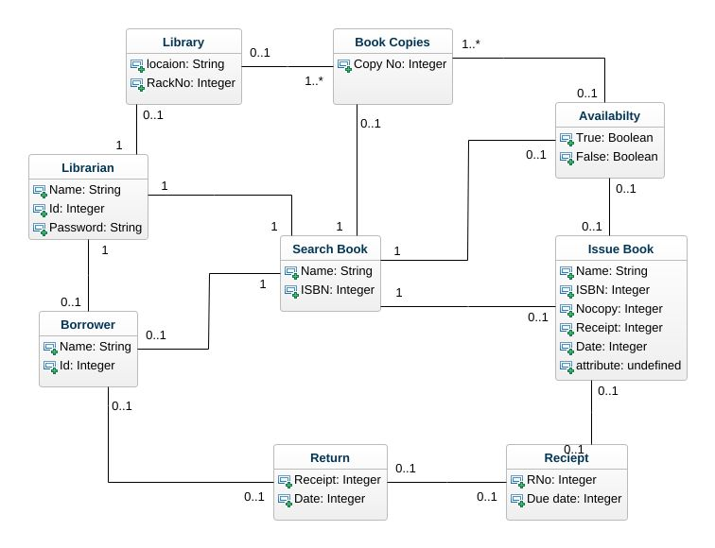

QUESTION No 5: Write Non-functional requirement of following two projects.

1. Bike racing game.
2. An online banking system.

ANSWER: Non functional requirement describe the qualities and properties that product must have such as ease of use, performance and human aspects. Following are some non functional requirements.

Bike racing game:

1. The interface must be user friendly.
2. The game must be fun.
3. The must not crash.
4. The game should have a story.
5. You will be able to drive vehicles